#
# 20190917
# Were received two alerts about run out free space on two Elasticsearch servers in Insurance.
#

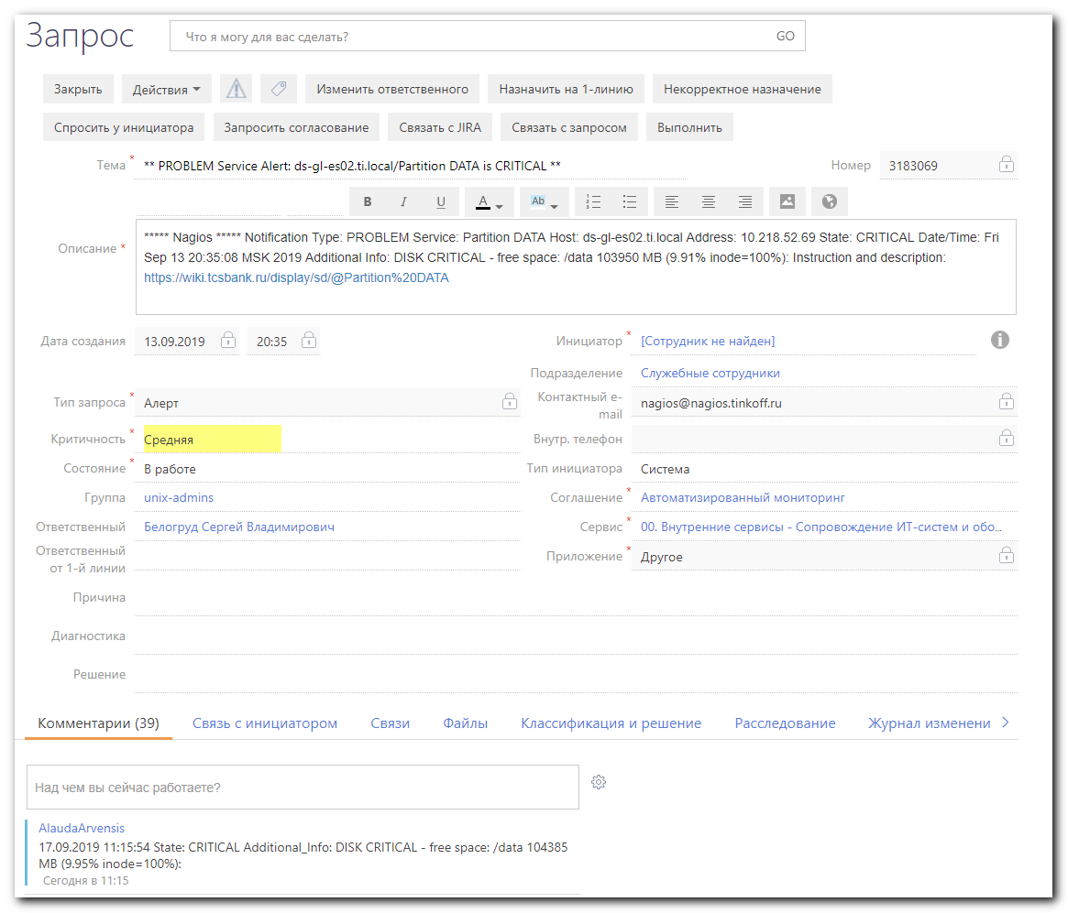

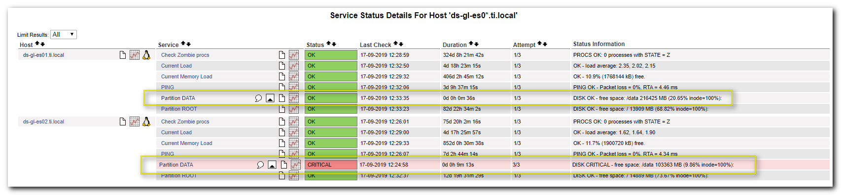

#
# The space was consumed by indices.
#
[root@ds-gl-es01 ~]# du -sh /data/elasticsearch/graylog2_prod/nodes/0/*
921G /data/elasticsearch/graylog2_prod/nodes/0/indices
0 /data/elasticsearch/graylog2_prod/nodes/0/node.lock
8.0K /data/elasticsearch/graylog2_prod/nodes/0/_state
[root@ds-gl-es01 ~]# df -hT /data
Filesystem Type Size Used Avail Use% Mounted on
/dev/sdb1 xfs 1.0T 925G 100G 91% /data
[root@ds-gl-es01 ~]#

# The same is on both servers.
[root@ds-gl-es02 ~]# du -sh /data/elasticsearch/graylog2_prod/nodes/0/*
921G /data/elasticsearch/graylog2_prod/nodes/0/indices
0 /data/elasticsearch/graylog2_prod/nodes/0/node.lock
8.0K /data/elasticsearch/graylog2_prod/nodes/0/_state
[root@ds-gl-es02 ~]#

#
# I’ve found, what port was listening on this server.
#
[root@ds-gl-es01 ~]# netstat -nlpt
Active Internet connections (only servers)
Proto Recv-Q Send-Q Local Address Foreign Address State PID/Program name
tcp 0 0 0.0.0.0:10050 0.0.0.0:* LISTEN 968/zabbix_agentd
tcp 0 0 0.0.0.0:5666 0.0.0.0:* LISTEN 714/nrpe
tcp 0 0 10.218.52.53:9200 0.0.0.0:* LISTEN 14132/java
tcp 0 0 10.218.52.53:9300 0.0.0.0:* LISTEN 14132/java
tcp 0 0 0.0.0.0:22 0.0.0.0:* LISTEN 939/sshd
tcp6 0 0 :::10050 :::* LISTEN 968/zabbix_agentd
[root@ds-gl-es01 ~]#

#
# Here I’ve seen cluster name. But, that was not helped me too much.
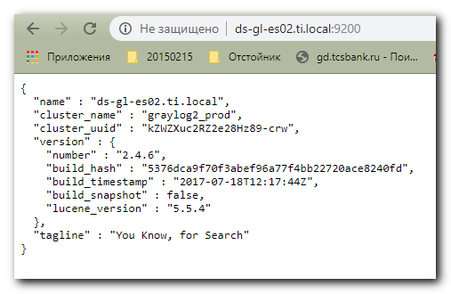

http://ds-gl-es02.ti.local:9200/

{
"name" : "ds-gl-es02.ti.local",
"cluster_name" : "graylog2_prod",
"cluster_uuid" : "kZWZXuc2RZ2e28Hz89-crw",
"version" : {
"number" : "2.4.6",
"build_hash" : "5376dca9f70f3abef96a77f4bb22720ace8240fd",
"build_timestamp" : "2017-07-18T12:17:44Z",
"build_snapshot" : false,
"lucene_version" : "5.5.4"
},
"tagline" : "You Know, for Search"
}

#
# Here is a place, where I can control indexes
#
http://graylog.ti.local/system/indices

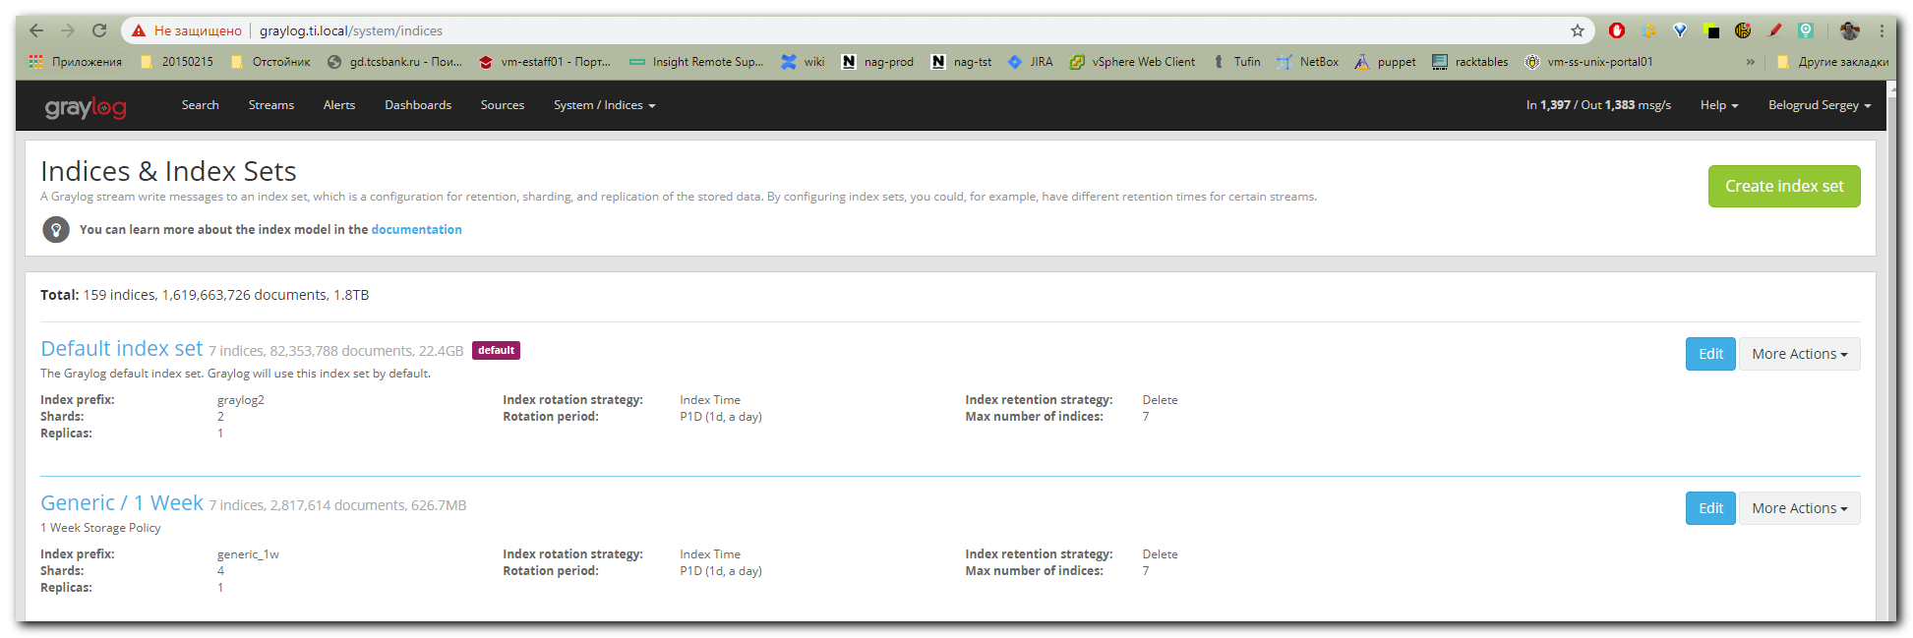

# I’ve found the biggest busy space and reduce number of indexes from 30 to 25.
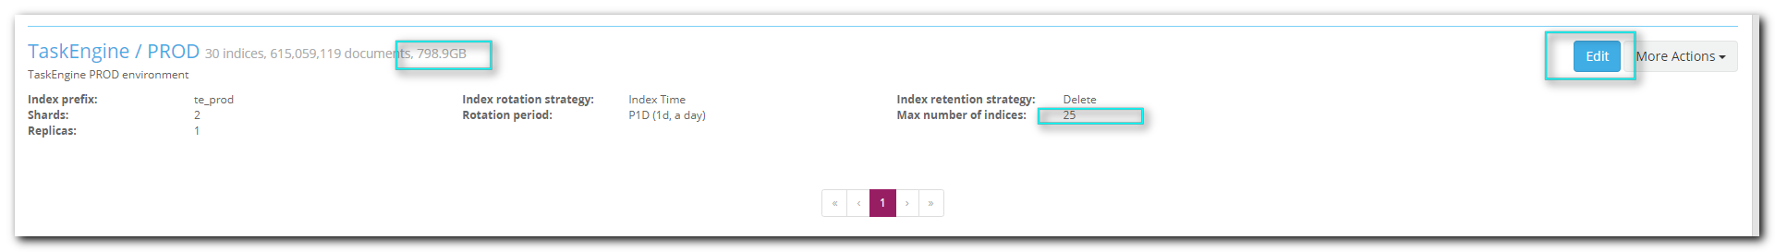

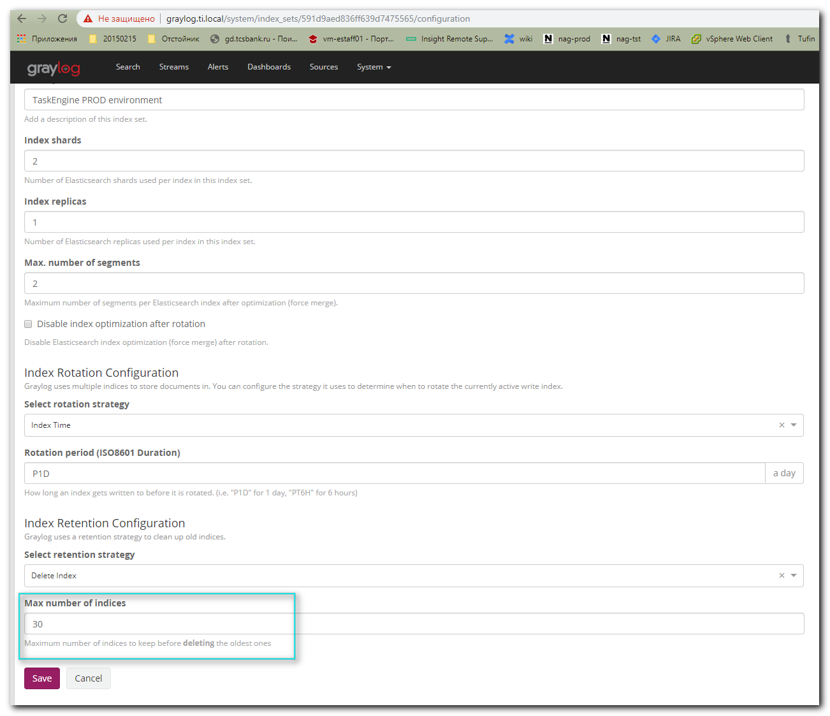

# Now amount of indexes are 25.
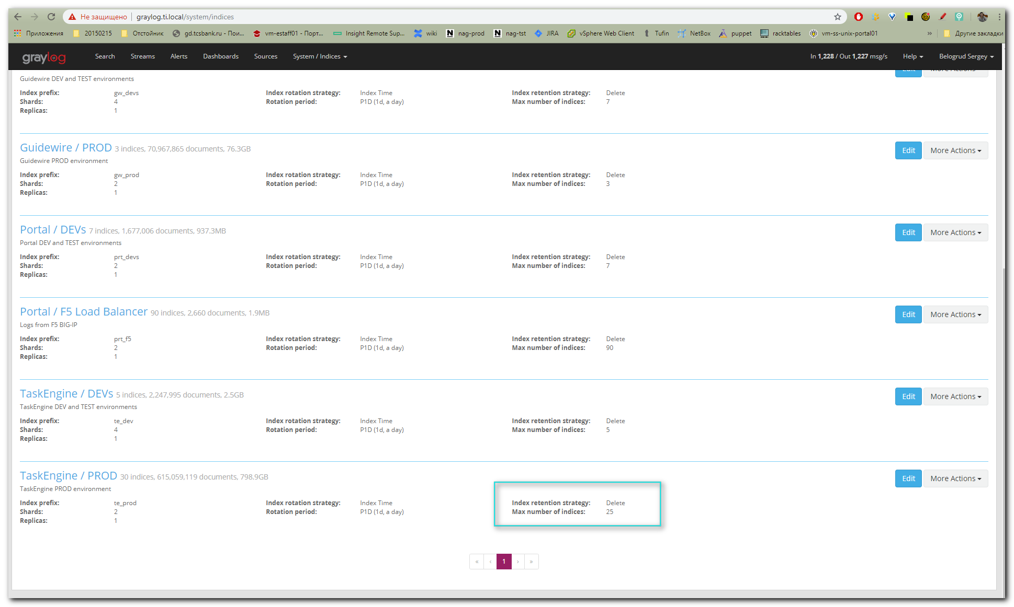

#
# I’ve tested info about count of indexes here.
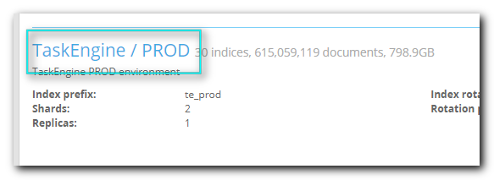
#
# Here are 25 records about indexes (or 24 if one of them is recording at this moment).
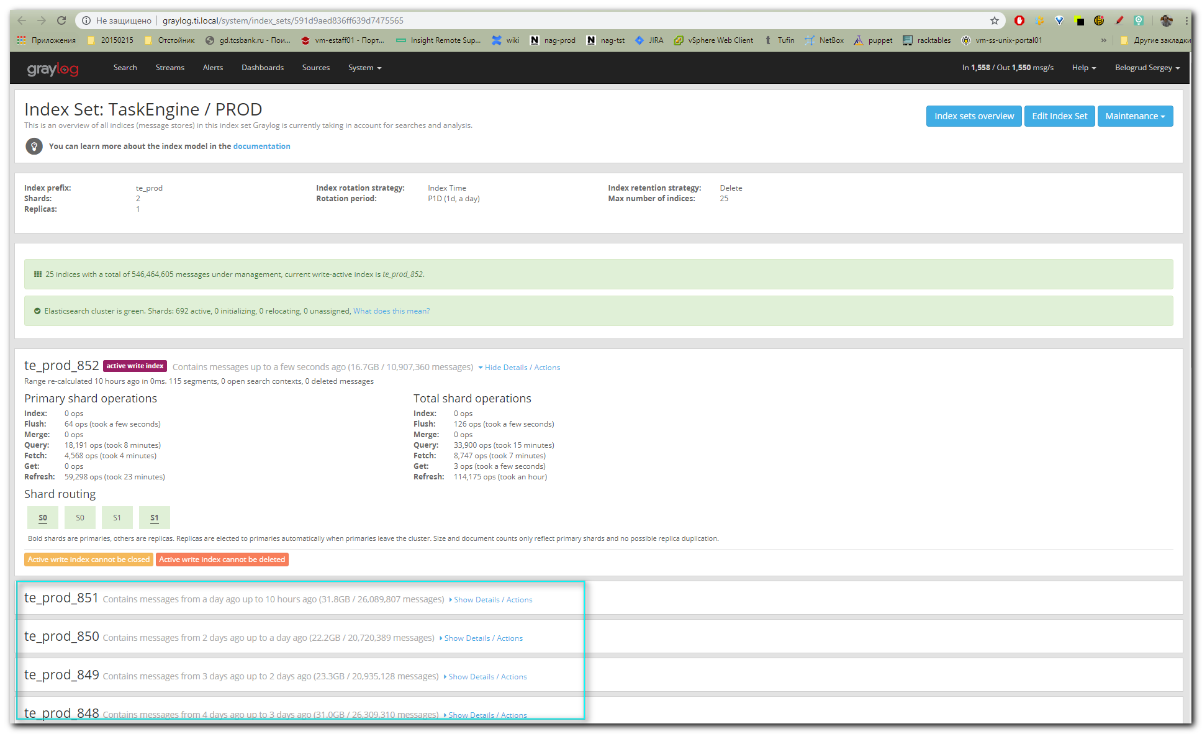

#
# After amount of indexes was reduced from 30 to 25, I’ve seen free space increased.

[root@ds-gl-es01 ~]# df -hT /data
Filesystem Type Size Used Avail Use% Mounted on
/dev/sdb1 xfs 1.0T 813G 212G 80% /data
[root@ds-gl-es01 ~]#

[root@ds-gl-es02 ~]# df -hT /data
Filesystem Type Size Used Avail Use% Mounted on
/dev/sdb1 xfs 1.0T 812G 212G 80% /data
[root@ds-gl-es02 ~]#

[root@ds-gl-es02 ~]# du -sh /data/elasticsearch/graylog2_prod/nodes/0/*
813G /data/elasticsearch/graylog2_prod/nodes/0/indices
0 /data/elasticsearch/graylog2_prod/nodes/0/node.lock
8.0K /data/elasticsearch/graylog2_prod/nodes/0/_state
[root@ds-gl-es02 ~]#

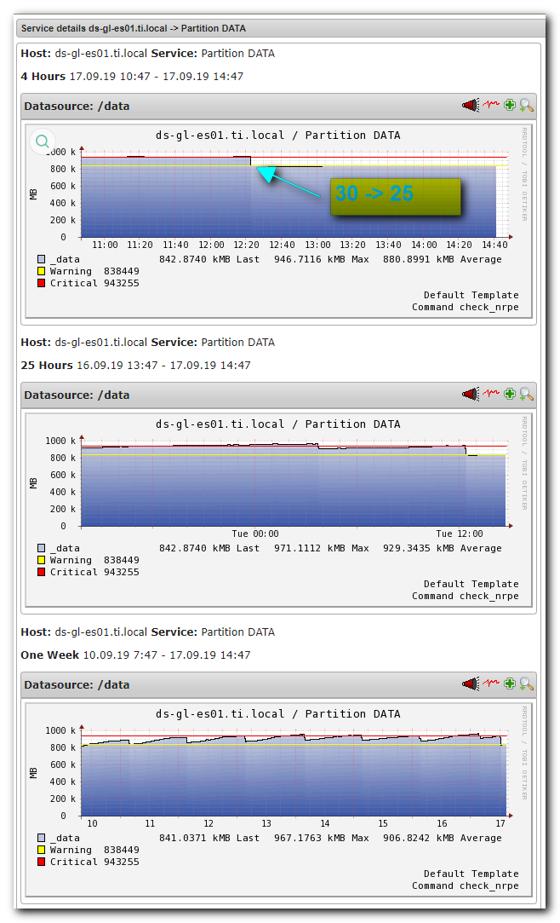
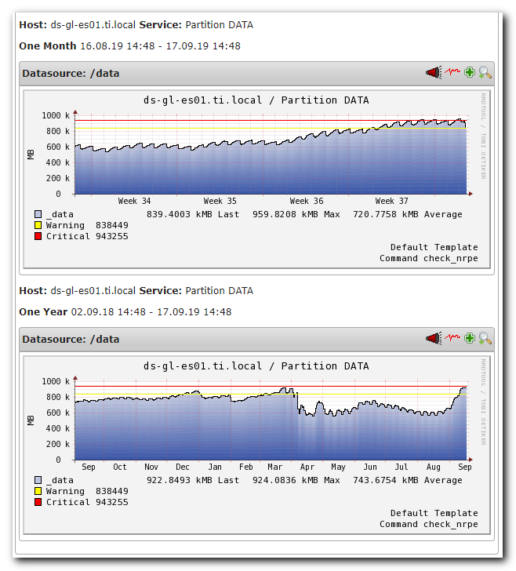

Изменил с 30 на 25 параметр "Max number of indices:" для индекс сета "TaskEngine / PROD" на http://graylog.ti.local.
Место на разделе /data освободилось.

https://www.elastic.co/guide/en/elasticsearch/reference/2.3/indices-delete-index.html

Delete Indexedit
The delete index API allows to delete an existing index.

$ curl -XDELETE 'http://localhost:9200/twitter/'
The above example deletes an index called twitter. Specifying an index, alias or wildcard expression is required.

The delete index API can also be applied to more than one index, by either using a comma separated list, or on all indices (be careful!) by using _all or * as index.

In order to disable allowing to delete indices via wildcards or _all, set action.destructive_requires_name setting in the config to true. This setting can also be changed via the cluster update settings api.

https://www.elastic.co/guide/en/elasticsearch/reference/current/indices-delete-index.html

Delete index APIedit
Deletes an existing index.

DELETE /twitter
Copy as cURL
View in Console

Requestedit
DELETE /<index>

Path parametersedit
<index>
(Request, string) Comma-separated list or wildcard expression of indices to delete.

In this parameter, wildcard expressions match only open, concrete indices. You cannot delete an index using an alias.

To delete all indices, use _all or * . To disallow the deletion of indices with _all or wildcard expressions, change the action.destructive_requires_name cluster setting to true. You can update this setting in the elasticsearch.yml file or using the cluster update settings API.

Query parametersedit
allow_no_indices
(Optional, boolean) If true, the request does not return an error if a wildcard expression or _all value retrieves only missing or closed indices.

This parameter also applies to index aliases that point to a missing or closed index.

expand_wildcards
(Optional, string) Controls what kind of indices that wildcard expressions can expand to. Valid values are:

all
Expand to open and closed indices.
open
Expand only to open indices.
closed
Expand only to closed indices.
none
Wildcard expressions are not accepted.
Defaults to open.

ignore_unavailable
(Optional, boolean) If true, missing or closed indices are not included in the response. Defaults to false.
timeout
(Optional, time units) Specifies the period of time to wait for a response. If no response is received before the timeout expires, the request fails and returns an error. Defaults to 30s.
master_timeout
(Optional, time units) Specifies the period of time to wait for a connection to the master node. If no response is received before the timeout expires, the request fails and returns an error. Defaults to 30s.

https://support.cloudbees.com/hc/en-us/articles/228366568-How-to-delete-an-index-on-Elasticsearch-

How to delete an index on Elasticsearch?
July 25, 2019 05:10
Follow

Issue
How to delete an index on Elasticsearch

Environment
- CloudBees Jenkins Operations Center

Resolution
In your web browser navigate to elasticsearchInstance:PORT/_aliases?pretty=1 .You should see output similar to what is shown in the screenshot below:
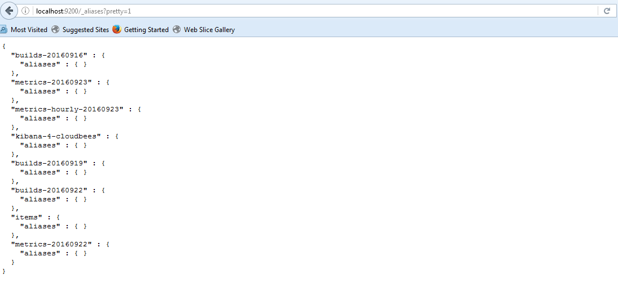
Make a note of the specific index or indices you would like to delete.
To delete a specific index you will need to run: curl -XDELETE http://localhost:9200/indexName/
To delete all occurrences of a specific index you can run: curl -XDELETE http://localhost:9200/indexName*/
The curl commands are based on the steps documented in the Elasticsearch documentation.
For example, using the build- indexes shown in the screenshot above the following curl commands will delete a specific index or all of the build- indexes:
To delete a builds-20160919 index you will need to run: curl -XDELETE http://elasticsearchInstance:PORT/builds-20160919/
To delete all occurrences of a builds- indexes you can run: curl -XDELETE http://elasticsearchInstance:PORT/builds-*/
Running the curl commands should produce output similar to the following:
C:\Windows\System32>curl -XDELETE http://localhost:9200/builds-20160919/
{"acknowledged":true}
C:\Windows\System32>curl -XDELETE http://localhost:9200/builds-20160916/
{"acknowledged":true}
C:\Windows\System32>curl -XDELETE http://localhost:9200/builds-*/
{"acknowledged":true}

If necessary the builds indexes can be recreated by setting up a cluster operation on CJOC to reindex the jobs on Jenkins as documented in the “Reindexing for CloudBees Jenkins Analytics” section here .

